***Elevated TA conditions influence juvenile oyster growth when combined with a lower salinity***

1,2Saley, Alisha M., 2Kimball, Zoe & 1,2Brian Gaylord

1 Bodega Marine Laboratory, University of California Davis

2 Dept. of Ecology and Evolution, University of California at Davis

***Abstract—***

Response trajectory—do effects change over time, bigger/small and ibn what direction

Reasonable expectations; which one plays out

***Introduction—*** Coastal estuaries exhibit variability in the seawater carbonate system, with implications for calcifying inhabitants. For example, biochemical processing and river inflows can cause gradients of total alkalinity (TA) over small distances (cite). Estuarine TA conditions are temporally complex, where conditions can change abruptly and persist for weeks to months, requiring sessile calcifiers to new conform to new conditions. Given the multi-faceted extent to which external seawater conditions dictate performance for marine calcifiers, investigating how responses to such variation in TA change through time, deserves specific attention.

Substantial effort has documented how calcifier growth can be disrupted by perturbations to the carbonate system. Some have emphasized the temporal nature of perturbed conditions, both within and across life stages, finding that the nature of exposure (statis vs fluctuating) and the life-stage at exposure (X vs X) can influence future growth performance (cite). A gap remains in our understanding of the degree to which responses may vary, between the initial period following exposure and a latent period, after an individual has experienced the new seawater condition for multiple weeks’ time. Following exposure to new conditions, many calcifiers conform their internal fluids to match external conditions, creating physiological trade-offs between investing energy into maintenance versus growth (shell or tissue). As such, overall patterns of net growth to variable conditions could look similar in individuals that, in fact, exhibited very different growth patterns through time.

Exploring how growth rate responds to altered TA conditions through time is a natural complement to prior work. Others have documented disrupted growth in many calcifiers following abrupt shifts to carbonate system conditions (cite), with substantial attention devoted to understanding the consequences of human-derived ocean acidification (for review see Gazeau et al 2013). Drastic drops in salinity also have consequences on growth (cite), though, diluted TA may have interacted with lower salinity. Observed declines in growth can signify metabolic downregulation (cite) and an unmet increase in energetic demand (cite), which could result in trade-offs between shell and tissue growth (cite). What remains unexplored is how growth may change over time in response to variable TA conditions, specifically in calcifiers known to experience, and tolerate, a wide range of conditions.

In estuaries, oysters have significant economic and ecological value to coastline habitats and communities. As oysters naturally form reefs, they provide habitat for other estuarine species (cite) and can protect shoreline from X (cite). Commercially, they are be grown and harvested for consumption, economically contributing to a growing human shellfish diet (cite). As such, emphasis is often placed on both growth of the shell and of tissue mass. Juvenile growth in particular can be sensitive to abrupt changes in conditions (cite), which, could result in trade-offs between shell or tissue growth (cite).

Here we explore the how influence of TA condition on surface area shell growth can vary between initial and latent periods in the juvenile Eastern oyster (*Crassostrea virginica*), depending on the salinity. We quantified incremental surface area growth of oyster valves across two time periods as a function of TA condition and accounted for the effect of oyster size at the start of the period, separately, in ambient and low salinity treatments. We did not observe differences in surface area growth initially among TA treatments, in either salinity. Growth rate patterns changed slightly in the latent period, where oysters in low salinity treatments combined with elevated TA exhibited higher growth rates than those in TA conditions simulating dilution with DI. Additionally, growth rates were lower in the latent period than the initial period, in all TA conditions. Given the known shifts between periods of energy assimilation and storage, shell growth, or tissue growth in oysters, we also compared average oyster shell thickness (shell mass per area) and condition index (tissue mass per shell mass) as a function of TA conditions. In ambient and salinity treatments, we did not see any trade-offs to tissue mass or shell thickness, as neither oyster shell thickness nor condition index varied as a function of TA condition. Examinations such as these lend insights into oysters may respond to abrupt changes in estuarine conditions through time.

***Methods—***

Fig. 1

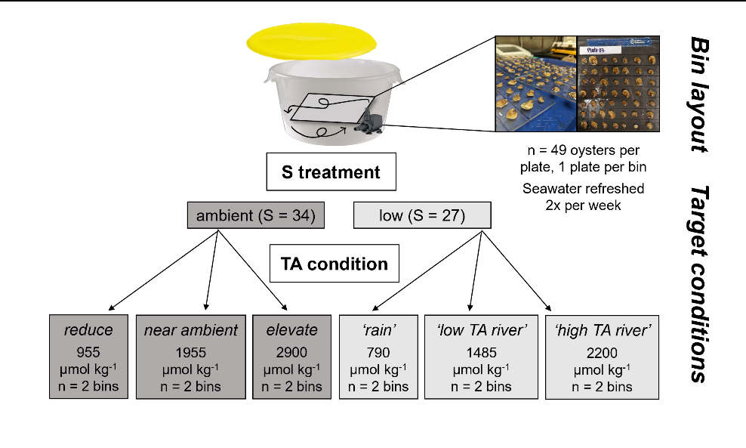

**Study species—** The Eastern oyster, *Crassostrea virginica*, is native to estuaries of eastern North America, from the Gulf of St. Lawrence to the Gulf of Mexico. (cite) Due in part to its wide salinity and thermal tolerance, this species is also grown commercially elsewhere, including X (cite), For our experiments, we sourced juvenile oysters from a local aquaculture farm in Tomales Bay, California, USA (Hog Island Oyster Company; coordinates). On 22 July 2022, we transported oysters in cool seawater from Tomales Bay to Bodega Marine Laboratory (BML; Bodega Bay, California, 60 min transit time), and placed them immediately into flow-through, continuously bubbled seawater drawn from the adjacent ocean. We fed the oysters with slow-release mixed algal diet (X% of their wet mass; [provide supplier]) every other day, throughout a 30-d lab acclimation period. At the end of the acclimation period, we glued the oysters (left valve) to plastic plates using X marine epoxy (n = 49 per plate, n = 12 plates) following X et al (cite year). We then returned the plates with attached oysters to the acclimation tanks, and three days hence began a pair of complementary, 36-d growth experiments (Fig. 1).

**Experiment 1—** In a first study component, we asked whether TA affects oyster shell growth in the simplest possible way, focusing on altered alkalinity in seawater of ambient salinity. We established two replicate cultures at ambient salinity (S=34) for each of three TA levels: 955, 1955, and 2900 µmol kg-1. The experimental design therefore encompassed 49 oysters x 2 static cultures x 3 alkalinity levels = 294 individuals, all at S = 34 (Fig. 1).

**Experiment 2—** In a second study component, we refined our perspective in recognition that oysters live preferentially in estuaries. Estuaries frequently experience decreased salinity, and declines in salinity can be accompanied by a range of TA levels. For instance, in estuaries that receive streams from watersheds of carbonate geology, salinity depressions can be associated with surprisingly high TA. In other cases, freshwater inputs may tie mostly to rain, which has negligible TA, leading to oysters experiencing low S joined with low TA. Given the range in possible TA conditions that can accompany low S, we used two replicate cultures at S=27 for each of three TA levels: 790, 1485, and 2200 µmol kg-1. The design for this second experiment thus contained 49 oysters x 2 static cultures x 3 alkalinity levels = 294 individuals, all at S = 27 (Fig. 1).

**Oyster growth—** During each of the two experiments, we tracked changes in shell surface area through time. Because a primary goal was to distinguish early from later growth patterns in oysters, we took photos of shell area on day 0, day 18, and day 36. The aim was to compare responses during the early time window (days 0-18) to those during the later time window (days 19-36). We analyzed the photos using ImageJ software (v.X) to determine projected surface area of each oyster’s top valve, ensuring a scale bar was visible in each image. We computed both the *growth in shell area* (difference in shell area between start and end dates), and *relative shell growth* (increase in shell area divided by initial area). We also measured condition index at the end of each of the experiments, which we quantified as dry tissue mass per dry shell mass, after separating the tissue from the shells and drying each at 60°C for 48 hr. We then divided shell mass by shell area to develop a rough metric of shell thickness.

**Culture conditions—** Each static culture during both experiments was bubbled vigorously with an air pump that also circulated the water. The air pump ensured that oxygen saturation remained >80%. The only exceptions were two cultures that dropped to X% on one occasion each due to pump failure. The resulting episodes of decreased oxygen lasted less than X hr. Oysters were fed daily [with X], and were held in the dark to minimize the influence of shadows on activity (cite). Complete water changes were done every three days, and the sides of the culture vessels, and pumps, cords, and tubing were cleaned of any fouling organisms and debris. The experimental cultures had lids, but were not tightly sealed due to a gap created by the pump power cord, which resulted in minor chemical drift between water changes (Fig. 2). Despite this drift, chemical conditions across treatments remained distinct and differed statistically. Any mortality of oysters (always <X%) was recorded at the same time as water changes, and shells of deceased oysters were promptly removed from the cultures and discarded.

Before and after each water change during both experiments, we measured seawater temperature, salinity, pH, and dissolved oxygen concentration with a handheld multi-parameter sensor (YSI X). In X percent of pH measurements, we collected and analyzed discrete bottle samples for spectrophotometric determination of pH (calibrated daily with m-cresol dye standards, Easley and Byrne 2015), and used the latter data to translate pH data to the total scale. We also collected and immediately froze 250 ml seawater samples before and after each water change for later alkalinity determination. We quantified seawater TA in triplicate using a Metrohm 855 Titrosampler, correcting titration acid concentration daily with certified reference materials from the laboratory of Dr. Andrew Dickson (Scripps Institute of Oceanography). Finally, we used measurements of seawater TA (µmol kg-1) and pH (total scale) at specified salinities and temperatures to estimate the remaining seawater carbonate system parameters with the *seacarb* package in the software R (version 3.3.1). In our *seacarb* estimates, we used equilibrium constants from Lueker et al. 2000 (K1 and K2), Perez and Fraga 1987 (Kf), and Dickson 1990 (Ks). For simplicity, we refer to the seawater carbonate system in terms of TA, though we emphasize that additional carbonate system parameters are required to fully describe seawater conditions (Table S1; see also Zeebe and Wolf-Gladrow 2001) and that these parameters may influence oyster growth separately from salinity and TA (cite).

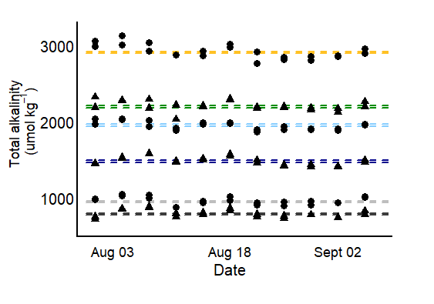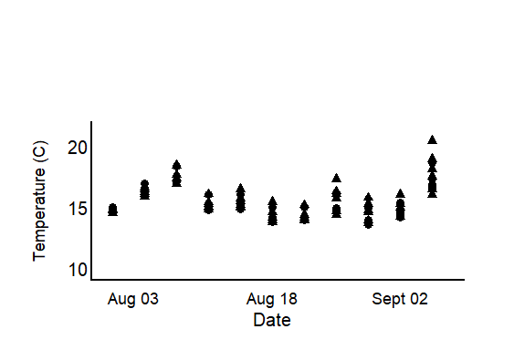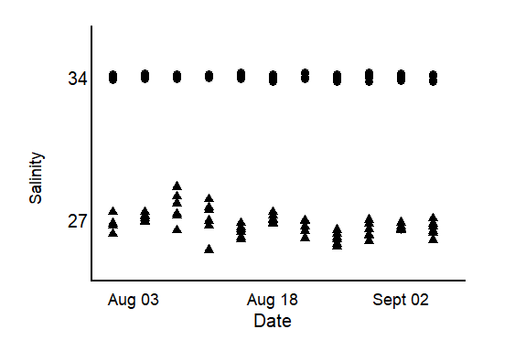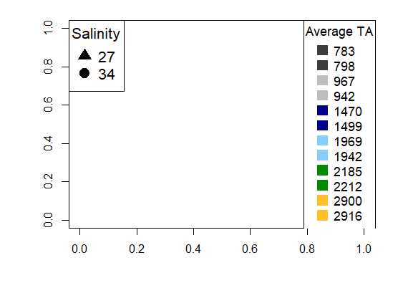

Fig. 2

**Chemical manipulation of seawater—** Seawater chemical conditions at the beginning of the two experiments and at each water change were established as follows. We first depleted seawater TA to negligible concentrations in large sumps (n = 4 sumps/water change) by adding hydrochloric acid (HCl) to drive the carbonate system reactions towards CO2, which then off-gassed over two days in conjunction with strong bubbling with air. We then mixed the TA-depleted seawater with distilled fresh water and to adjust the carbonate system back to desired salinity and TA levels (Waldbusser et al. 2015, Ninokawa et al. in review).

**Statistical analysis—** All statistical tests were performed in R Studio (ver. 2022.07.02). We used mixed effects models (*nlme*, *lme4*) to explore how TA affects shell growth over the course of an exposure trajectory, at a given salinity, for each of our two experiments. At a given salinity, we first tested whether TA and oyster size affected shell growth over an 18 d duration. The 18 d duration corresponded to either the early response window (days 0-18) or the later response window (days 19-36). Total alkalinity was considered a fixed factor, and oyster size (projected surface area at the beginning of the time window under consideration) a continuous predictor. Culture vessel was included as a random intercept to account for lack of independence among oysters growing on the single plate placed in each culture. We used similar models to test the influence of TA and oyster size on relative growth rate, again at a specified salinity. The influence of TA on shell thickness (shell mass per area, mg mm-2) and condition index (tissue mass per shell mass, mg mg-2) was also tested, dropping the term for oyster size that was used in other models, but including culture vessel again as a random intercept. We added a weighted variance term to models that failed the Breusch-Pagan test (*lmtest*) for residual heteroscedasticity, which specifies that the weight of each data point equal the proportional variance across TA levels. Assumptions of normality were visually verified with qqplots and histograms of model residuals.

***Results—***

**Incremental surface area growth—** Surface area growth rates were higher in the initial period of the response trajectory, relative to later on, but did not initially differ among TA conditions within ambient nor lower salinity treatments (). The effect of TA condition on shell growth manifested in the later increment, where oysters exposed to the highest TA condition (within ambient or low salinity) tended to have elevated rates of surface area shell growth, though only in low salinity treatments was the trend found to be significant ().

In addition to TA condition, size of the individual separately influenced oyster surface area growth. Oyster growth rates X as a function of initial shell area, indicating that surface area growth was X. We saw X effect of surface area on initial growth, and X effect in latent growth in ambient salinity. That is X to oysters in low salinity, where X happened.

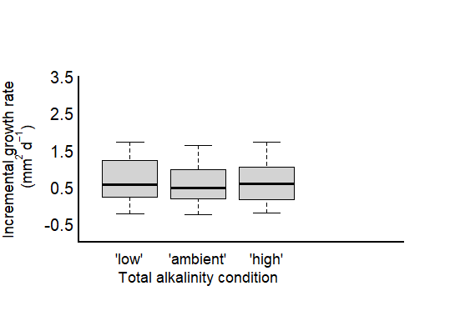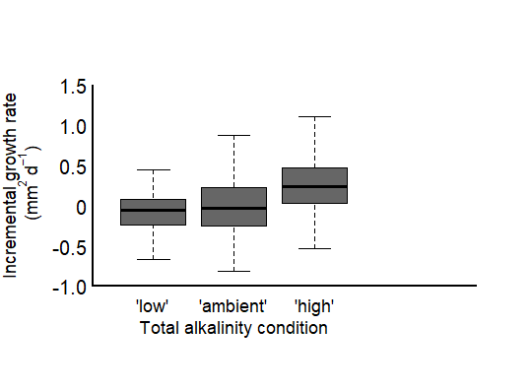

*days 0 - 18*

*days 18 - 36*

Fig. 2

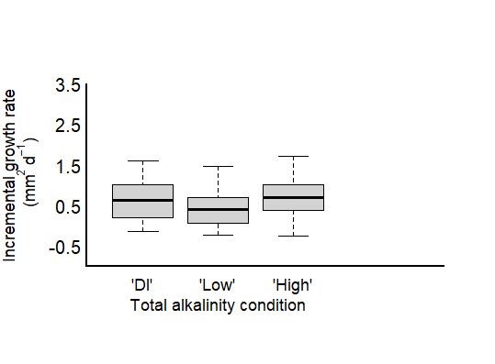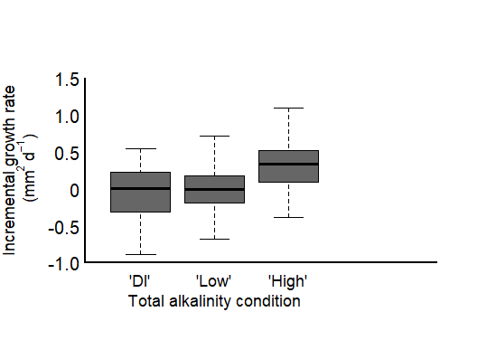

a

ab

b

*days 0 - 18*

*days 18 - 36*

Fig. 2

**Net growth—** The sum effect of TA condition and initial size on surface area growth was greater in oysters at lower salinity than those exposed to ambient. Specifically net surface area growth, like initial incremental growth, did not differ among TA conditions in oysters exposed to ambient salinity. Net surface area growth under lower salinity conditions was lower in DI TA conditions than high TA conditions, but low TA conditions did not significantly differ from either. Initial area size was again showing X.

Although TA impacted net lateral growth in some conditions, it did not influence average shell mass per area, a proxy for shell thickness, when coupled with either ambient or lower salinity. Similarly, we did not see a difference in oyster condition index across TA conditions or salinities. Average tissue mass greatly exceeded that of un-fed oysters held in lab seawater (X vs X) indicating an ability of all oysters to assimilate and store food as tissue mass. Condition index in high TA and lower salinity did not statistically differ, suggesting that oysters in this condition not only increased their surface area, but also tissue mass overall.

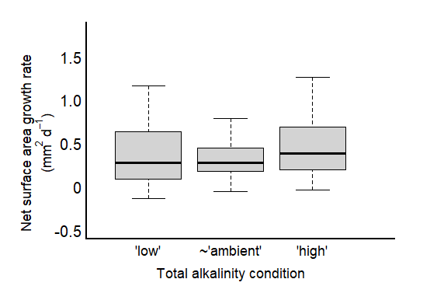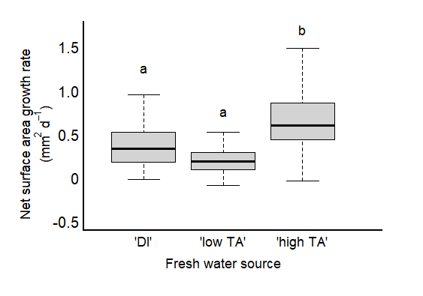

Fig. 4

A severe decline in growth rate between initial and latent increments could indicate a switch between shell growth and tissue growth, however, due to not wanting to sacrifice individuals following the first increment, we lack tissue mass samples to corroborate.

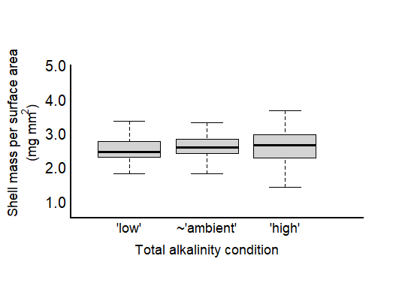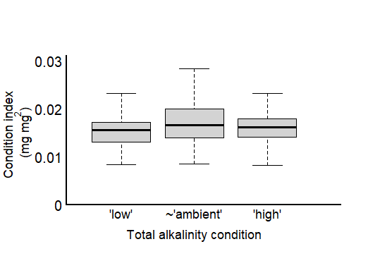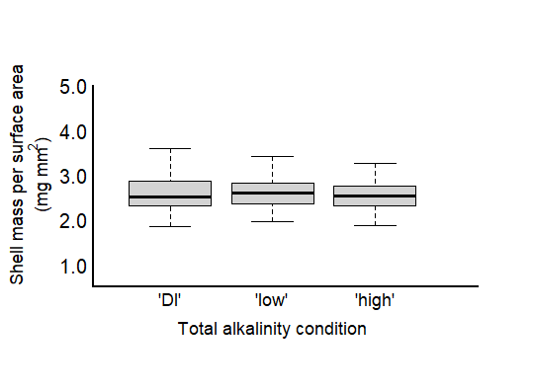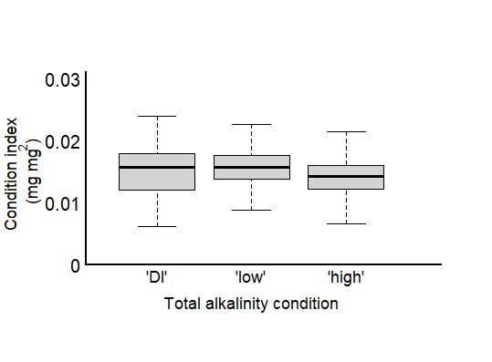

*(S = 34)*

*(S = 34)*

*(S = 27)*

*(S = 27)*

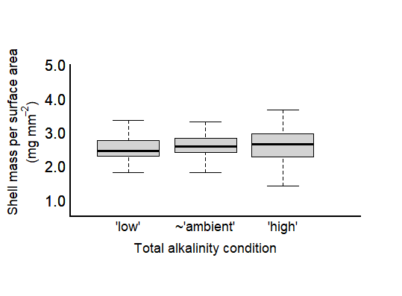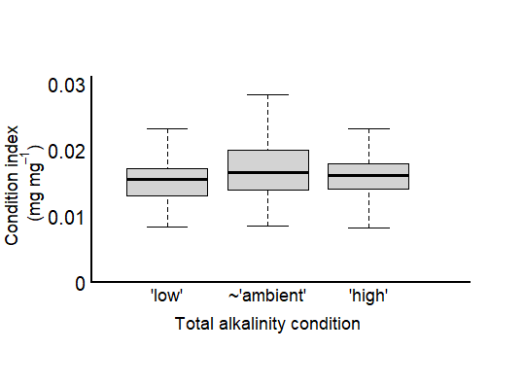

Fig. 2

***Discussion—***

Table X. Results of mixed effects, linear model testing the effects of factor(TA condition) and factor(experimental increment) on incremental surface area growth rates (mm2 d-1) in juvenile *Crassostrea virginica* oysters grown in **ambient salinity**. Change in surface area is relative to the size of the oyster at the beginning of the experimental increment (initial (0-18) or at day 18 (18-36). L-Ratios and p-values were recorded during backward stepwise model selection and refer to the ANOVA test output between the full model and a model with the specified predictor omitted. Bolded values denote a significant effect, determined by alpha < 0.05. The final model: Incremental growth rate ~ factor(TA condition) + factor(experimental increment) + RI(bin) + weight = by(TA condition), accounted for ~ X% of the variation.

|  |  |  |  |  |  |  |
| --- | --- | --- | --- | --- | --- | --- |
| **Model A: Initial (0-18 days) surface area growth rate (mm2 d-1) in ambient salinity** | | | | | | |
| **Fixed Effects**  marg. r2 = 0.62  cond. r2 = 0.63 | **Estimate** | **Std. Error** | **t-value** | **df** |  | **p-value** |
|  |  |  |  |  |  |  |
|  |  |  |  |  |  |  |
|  |  |  |  |  |  |  |
|  |  |  |  |  |  |  |
| **Random Effects** | **Intercept** | **Residual** |  |  | **L. Ratio** | **p-value** |
| Bin |  |  |  |  |  |  |

|  |  |  |  |  |  |  |
| --- | --- | --- | --- | --- | --- | --- |
| **Model B: Latent (18 - 36 days) surface area growth rate (mm2 d-1) in ambient salinity** | | | | | | |
| **Fixed Effects**  marg. r2 = 0.31  cond. r2 = 0.35 | **Estimate** | **Std. Error** | **t-value** | **df** |  | **p-value** |
|  |  |  |  |  |  |  |
|  |  |  |  |  |  |  |
|  |  |  |  |  |  |  |
|  |  |  |  |  |  |  |
| **Random Effects** | **Intercept** | **Residual** |  |  | **L. Ratio** | **p-value** |
| Bin |  |  |  |  |  |  |

Table X. Results of mixed effects, linear model testing the effects of factor(TA condition) and factor(experimental increment) on incremental surface area growth rates (mm2 d-1) in juvenile *Crassostrea virginica* oysters grown in **low salinity**. Change in surface area is relative to the size of the oyster at the beginning of the experimental increment (initial (0-18) or at day 18 (18-36). L-Ratios and p-values were recorded during backward stepwise model selection and refer to the ANOVA test output between the full model and a model with the specified predictor omitted. Bolded values denote a significant effect, determined by alpha < 0.05. The final model: Incremental growth rate ~ factor(TA condition) + factor(experimental increment) + RI(bin) + weight = by(TA condition), accounted for ~ X% of the variation.

|  |  |  |  |  |  |  |
| --- | --- | --- | --- | --- | --- | --- |
| **Model A: Initial (0-18 days) surface area growth rate (mm2 d-1) in low salinity** | | | | | | |
| **Fixed Effects**  marg. r2 = 0.62  cond. r2 = 0.63 | **Estimate** | **Std. Error** | **t-value** | **df** |  | **p-value** |
|  |  |  |  |  |  |  |
|  |  |  |  |  |  |  |
|  |  |  |  |  |  |  |
|  |  |  |  |  |  |  |
| **Random Effects** | **Intercept** | **Residual** |  |  | **L. Ratio** | **p-value** |
| Bin |  |  |  |  |  |  |

|  |  |  |  |  |  |  |
| --- | --- | --- | --- | --- | --- | --- |
| **Model B: Latent (18 - 36 days) surface area growth rate (mm2 d-1) in low salinity** | | | | | | |
| **Fixed Effects**  marg. r2 = 0.31  cond. r2 = 0.35 | **Estimate** | **Std. Error** | **t-value** | **df** |  | **p-value** |
|  |  |  |  |  |  |  |
|  |  |  |  |  |  |  |
|  |  |  |  |  |  |  |
|  |  |  |  |  |  |  |
| **Random Effects** | **Intercept** | **Residual** |  |  | **L. Ratio** | **p-value** |
| Bin |  |  |  |  |  |  |

Table X. Results of mixed effects, linear model testing the effects of factor(TA condition) and factor(experimental increment) on surface area growth rates (mm2 d-1) in juvenile *Crassostrea virginica* oysters grown in **ambient or low salinity**. Change in surface area is relative to the size of the oyster at the beginning of the experimental increment (initial (0-18) or at day 18 (18-36). L-Ratios and p-values were recorded during backward stepwise model selection and refer to the ANOVA test output between the full model and a model with the specified predictor omitted. Bolded values denote a significant effect, determined by alpha < 0.05. The final model: Incremental growth rate ~ factor(TA condition) + factor(experimental increment) + RI(bin) + weight = by(TA condition), accounted for ~ X% of the variation.

|  |  |  |  |  |  |  |
| --- | --- | --- | --- | --- | --- | --- |
| **Model A: Net surface area growth rate (mm2 d-1) in ambient salinity** | | | | | | |
| **Fixed Effects**  marg. r2 = 0.62  cond. r2 = 0.63 | **Estimate** | **Std. Error** | **t-value** | **df** |  | **p-value** |
|  |  |  |  |  |  |  |
|  |  |  |  |  |  |  |
|  |  |  |  |  |  |  |
|  |  |  |  |  |  |  |
| **Random Effects** | **Intercept** | **Residual** |  |  | **L. Ratio** | **p-value** |
| Bin |  |  |  |  |  |  |
| **Model A: Net surface area growth rate (mm2 d-1) in low salinity** | | | | | | |
| **Fixed Effects**  marg. r2 = 0.62  cond. r2 = 0.63 | **Estimate** | **Std. Error** | **t-value** | **df** |  | **p-value** |
|  |  |  |  |  |  |  |
|  |  |  |  |  |  |  |
|  |  |  |  |  |  |  |
|  |  |  |  |  |  |  |
| **Random Effects** | **Intercept** | **Residual** |  |  | **L. Ratio** | **p-value** |
| Bin |  |  |  |  |  |  |

Table X. Results of mixed effects, linear model testing the effects of starting size (mm2) and TA condition (factor) on (a) net surface area growth rates (mm2 d-1) and (b) shell mass per area in juvenile *Crassostrea virginica* oysters grown in **ambient** salinity. L-Ratios and p-values were recorded during backward stepwise model selection and refer to the ANOVA test output between the full model and a model with the specified predictor omitted. Bolded values denote a significant effect, determined by alpha < 0.05. The final models, Net growth rate ~ starting size + factor(TA condition) + RI(bin) + weight = by(TA condition) and Shell mass per area ~ starting size + factor(TA condition) + RI(bin) + weight = by(TA condition) accounted for ~ X and X% of the variation, respectively.

|  |  |  |  |  |  |  |
| --- | --- | --- | --- | --- | --- | --- |
| **Model A: Net growth, Shell mass per shell area (mg mm-2) in ambient salinity** | | | | | | |
| **Fixed Effects**  marg. r2 = 0.24  cond. r2 = 0.41 | **Estimate** | **Std. Error** | **t-value** | **df** | **L. Ratio** | **p-value** |
| Intercept (factor (low TA)) |  |  |  |  |  |  |
| Starting size (mm2) |  |  |  |  |  |  |
| factor (mid TA) |  |  |  |  |  |  |
| factor (elevated TA) |  |  |  |  |  |  |
| **Random Effects** | **Intercept** | **Residual** |  |  | **L. Ratio** | **p-value** |
| Bin | **z** |  |  |  |  |  |

|  |  |  |  |  |  |  |
| --- | --- | --- | --- | --- | --- | --- |
| **Model B: Net growth, Condition index in ambient salinity** | | | | | | |
| **Fixed Effects**  marg. r2 = 0.02  cond. r2 = 0.02 | **Estimate** | **Std. Error** | **t-value** | **df** |  | **p-value** |
| Intercept (factor (low TA)) |  |  |  |  |  |  |
| factor (mid TA) |  |  |  |  |  |  |
| factor (elevated TA) |  |  |  |  |  |  |
| **Random Effects** | **Intercept** | **Residual** |  |  | **L. Ratio** | **p-value** |
| Bin |  |  |  |  |  |  |

Table X. Results of mixed effects, linear model testing the effects of starting size (mm2) and TA condition (factor) on (a) net surface area growth rates (mm2 d-1) and (b) shell mass per area in juvenile *Crassostrea virginica* oysters grown in **low** salinity. L-Ratios and p-values were recorded during backward stepwise model selection and refer to the ANOVA test output between the full model and a model with the specified predictor omitted. Bolded values denote a significant effect, determined by alpha < 0.05. The final model: The final models, Net growth rate ~ starting size + factor(TA condition) + RI(bin) + weight = by(TA condition) and Shell mass per area ~ starting size + factor(TA condition) + RI(bin) + weight = by(TA condition) accounted for ~ X and X% of the variation, respectively. We tested for differences in the TA conditions by looking for overlap in confidence intervals given by the model and are labeled as such.

|  |  |  |  |  |  |  |
| --- | --- | --- | --- | --- | --- | --- |
| **Model A: Net growth, shell mass per shell area (mg mm-2) in low salinity** | | | | | | |
| **Fixed Effects**  marg. r2 = 0.45  cond. r2 = 0.54 | **Estimate** | **Std. Error** | **t-value** | **df** | **L. Ratio** | **p-value** |
| Intercept (factor (low TA)) |  |  |  |  |  |  |
| Starting size (mm2) |  |  |  |  |  |  |
| factor (mid TA) |  |  |  |  |  |  |
| factor (elevated TA) |  |  |  |  |  |  |
| **Random Effects** | **Intercept** | **Residual** |  |  | **L. Ratio** | **p-value** |
| Bin |  |  |  |  |  |  |

|  |  |  |  |  |  |  |
| --- | --- | --- | --- | --- | --- | --- |
| **Model B: Net growth, Condition index in low salinity** | | | | | | |
| **Fixed Effects**  marg. r2 = 0.02  cond. r2 = 0.02 | **Estimate** | **Std. Error** | **t-value** | **df** |  | **p-value** |
| Intercept (factor (low TA)) |  |  |  |  |  |  |
| factor (mid TA) |  |  |  |  |  |  |
| factor (elevated TA) |  |  |  |  |  |  |
| **Random Effects** | **Intercept** | **Residual** |  |  | **L. Ratio** | **p-value** |
| Bin |  |  |  |  |  |  |